Troll Cat

Official Design Document

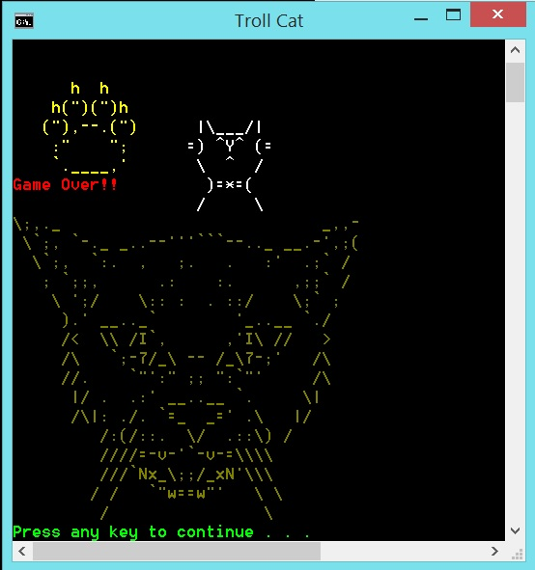

Copyright 2014 Team FOL

A Game Proposal By:

143343M Lim Wei Heng,

140522J Almeda Glenn Paolo Maestro,

143182M Toh Yi Fun Troy,

142471B Brandon Tan.

Target Audience

* 3 years old and above

Game Concepts

- Game Concept

- Genre

- Retro 1980s Handheld Game

- Game Goals

- To allow players of the modern era experience the previous era of gaming

- Have a very basic understanding on cat behaviour (ie. Cats get excited easily over moving objects)

- References

- Cat behaviour

- Laser pointers

- Octopus (1980s game)

Story

- Genre

- Classical LCD game

- High Concept

- Players will play with the cat using their laser pointer.

- Synopsis

- You decided that it is time to play with your cat. Using your laser pointer, you attract its attention with its bright light. Pulled by its magnificence, it starts to chase after it and it is up to you to keep it occupied by avoiding its impulsive attacks.

Gameplay

- Overview

- This section elaborates on general mechanics of the game.

- Abilities and Controls

- Basic Controls

- Directional pad to move the laser pointer which is represented as a red dot or a red “0”

- HUD

- Health Points is displayed on the top left corner of the screen

- Current Score is displayed on the top right corner of the screen

User Interface

- Overview

- Four main UI screens will be used throughout: Title, Play Game, Options and Exit Screens.

- Title

- This screen will host the following options: Play Game, Options and Exit screens.

- User is expected to enter a number to define the choice given.

- Play Game

- This screen is the main gameplay of the game. The player will get to play the game until he loses all his health points or he decides to quit the game.

- Options

- This screen will lead to the following options: How to Play and Highscores

- How-to-Play screen will provide a general set of instructions to assist the player in learning how to play the game.

- Highscores screen will provide a set of data related to a names of player and their corresponding score

- Exit

- This will allow the player to exit the game if he chooses this screen.

- The player will be given a prompt to reconsider his option.

Technical Design

- Overview

- To create the game, we made use of Microsoft Visual Studios 2010 and Notepad programs

- Microsoft Visual Studios 2010

- The bulk of the programming has been done in this platform.

- Making use of the provided framework (SP1), we worked on the codes related to game mechanics and dynamics

- Notepad

- Text files is used to help print out aesthetics-related material for the game

- It is also used to save critical data to display the Highscores should the player want to view it.

- Animation

- Overview

- This section elaborates on the animation schemes used in this project

- ASCII Art

- Codes related to the ASCII family is used to provide visual appeal. Most art is related to the cat with the exception of the player’s laser pointer

- Colour Coding

- Colours are used to help indicate the current game status to the player.

- User Interface

- A set of colours was chosen to help identify Health Points and Score. Every second in game will give the player 1 score point

- If the player gets hit by the cat tail or cat paw, the Health Points will deplete for as long as it is in the hit zone.

- Frames per second

- Expected amount of frames per second is 5. Certain flickering effects are expected but it should not affect the gameplay adversely.

- Rewards

- Overview

- The score is increased by each second.

- The cat paw will move at random positions of the game space in a progressive manner.

- Camera

- Overview

- The camera angle is considered to be overhead. It is not adjustable.

- Sound

- FX

- One beep sound to signal successful movement of player

- Development

- Overview

- The development of the game is documented in this section.

- First Phase

- This is when our game production was in its early stages. We established the fundamentals of the game here.

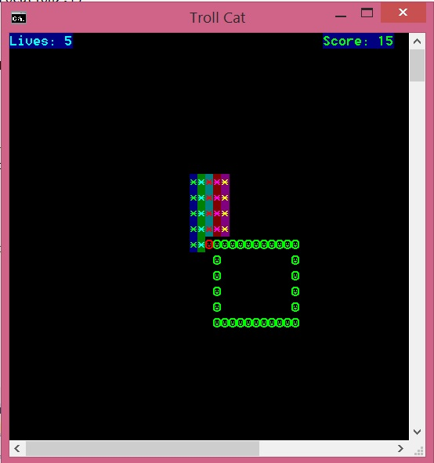

* Red dot = Player’s position
* Green square = Danger zone
* Coloured square = Dead zone (players cannot access this area)
* Second Phase  
  - The game mechanics and aesthetics have been improved.

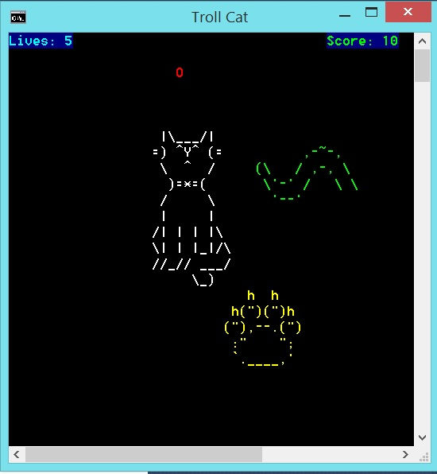

* Game Over screen
  + We also included the “Game Over” component when all lives have been depleted



* Phase 3
  + The general sense of difficulty and the indicator for player’s life has been changed and increased.

